

eProject Document
XYZ Pharmaceuticals
Group 6
Members | PHẠM ĐÌNH BÁCH-B8948(Team Leader)  ĐỖ VĂN MINH-B8924
Instructor | Lai Duc Chung
Batch | C2009G2
Semester | III

 Date of issue 31-10-2022 
 End date 30-11-2022 

Hardware and Software Requirements

Minimum Hardware Requirements
- CPU: Core Dual 2.00 GHz.
- RAM: 2GB.
- SDD/HDD: 2 GB (free).

Recommended Hardware Requirements
- CPU: Core i3 2.00 GHz.
- RAM: 4GB.
- SDD/HDD: 5 GB (free).
- OS: Window 8/10/11

Software Requirements
- Environment: Microsoft .NET Framework 4.5 or later
- Database Management System: Microsoft SQL Server 2014 or later
- IDE: Microsoft Visual Studio 2019 or later
- Web Server: Internet Information Services (IIS 7.0) or later
- Chrome or Microsoft Edge.

Install Application “XYZ Pharmaceuticals”.

Database Of Application
- Step 1 : Start→ SQL Server Management Studio 18.
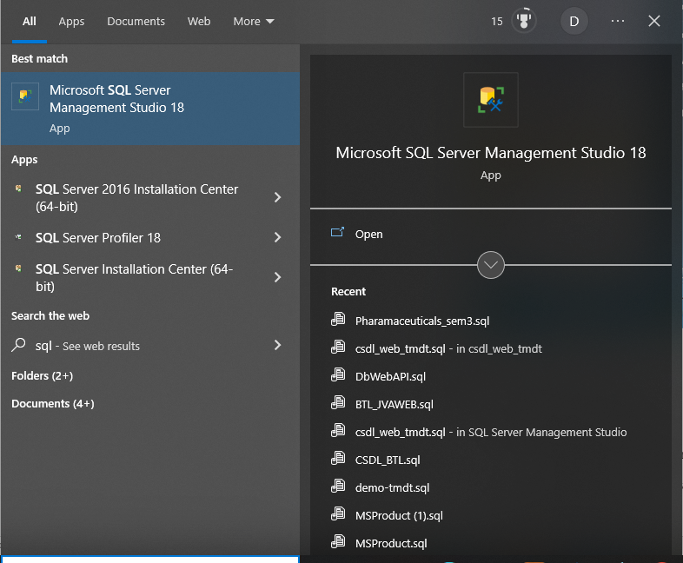

- Step 2 : Login in SQL Server :
- Enter information necessary :
  - Authentication : SQL Server Authentication.
  - Login and password of your computer.
- Click button “Connect”.

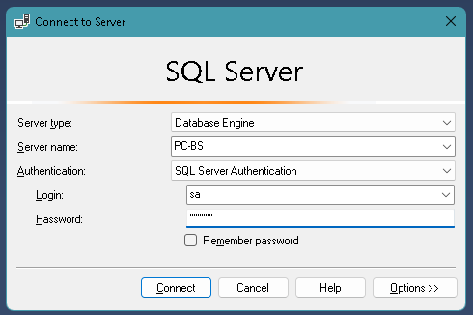

- Step 3 : Create Pharmaceuticals database
- Click → New Query
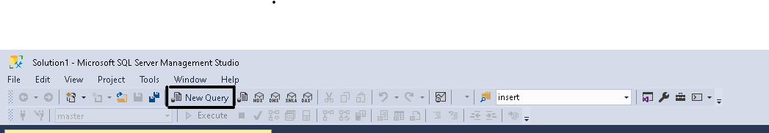
- Write “Create database Pharmaceuticals“ in Query tab then Click → Execute
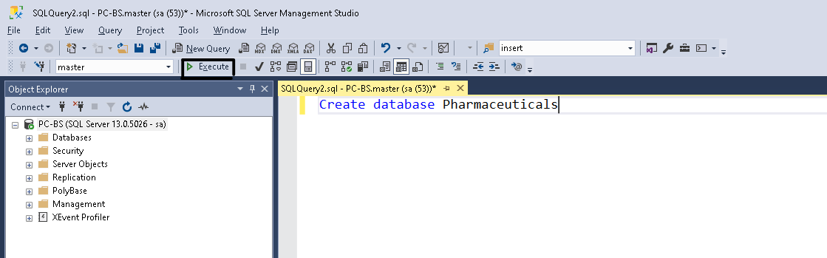
- Add table for database
- Open folder :
XYZ Pharmaceuticals → Pharmaceuticals → PharmaceuticalsAPI → Pharmaceuticals.sln

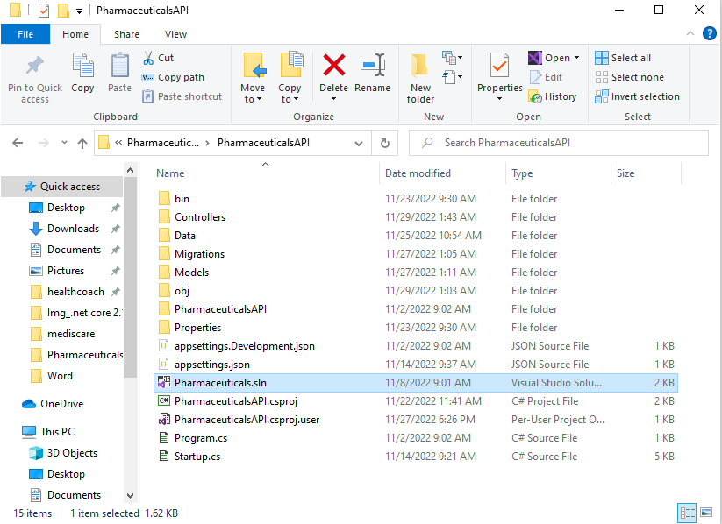

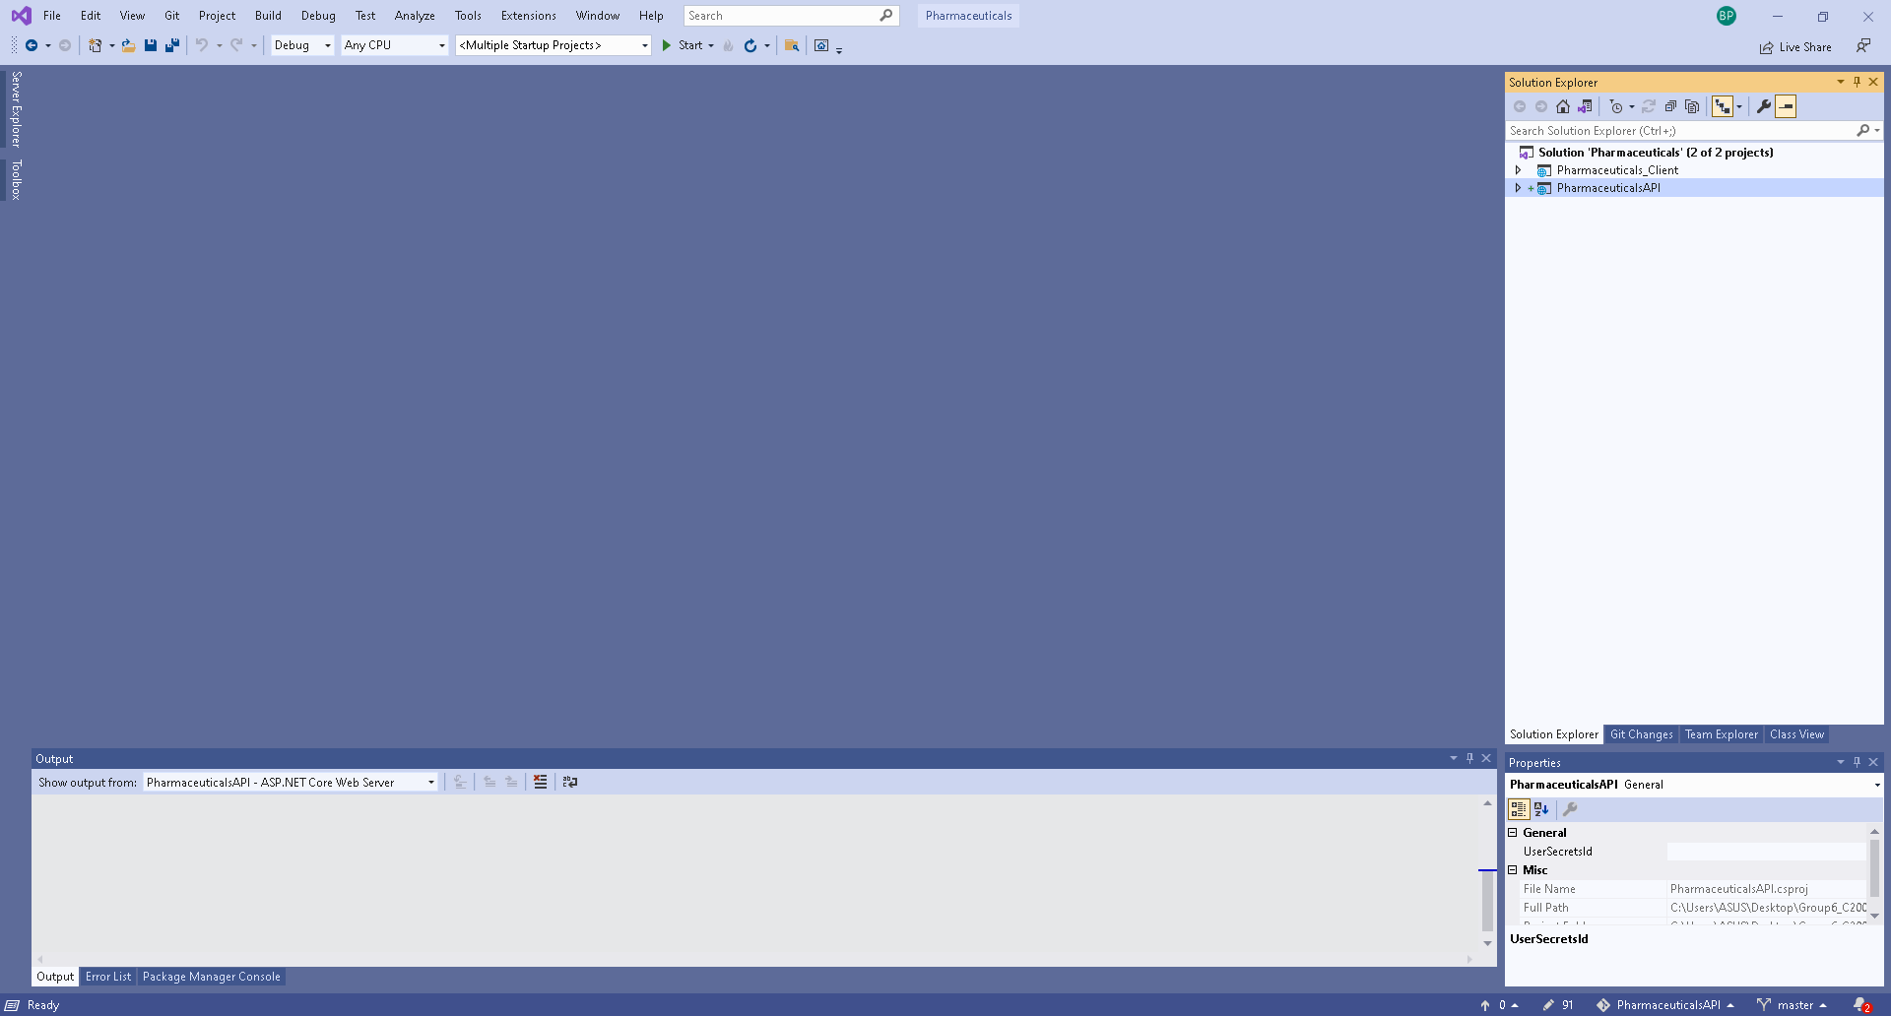

Click PharmaceuticalsAPI → appsettings.json
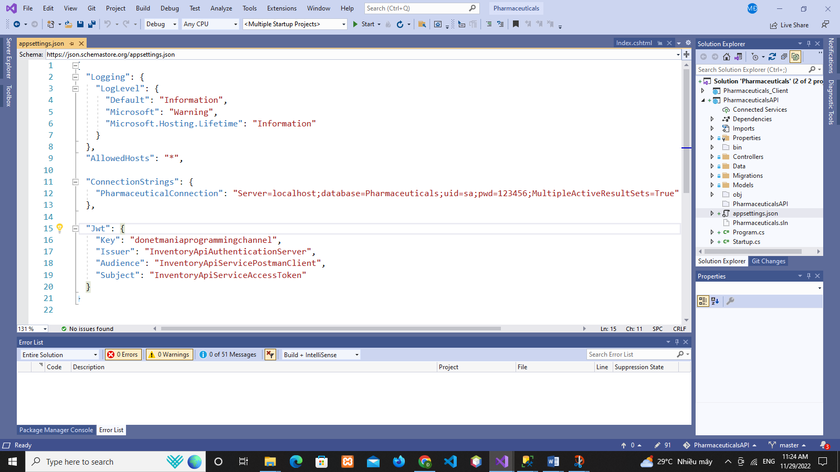
"ConnectionStrings": {
"PharmaceuticalConnection": "Server=localhost;database=Pharmaceuticals;uid=sa;pwd=123456;MultipleActiveResultSets=True"
}

- uid and pwd is the login information of your SQL Server

Click → Tools → NuGet Package Manager → Package Manager Console

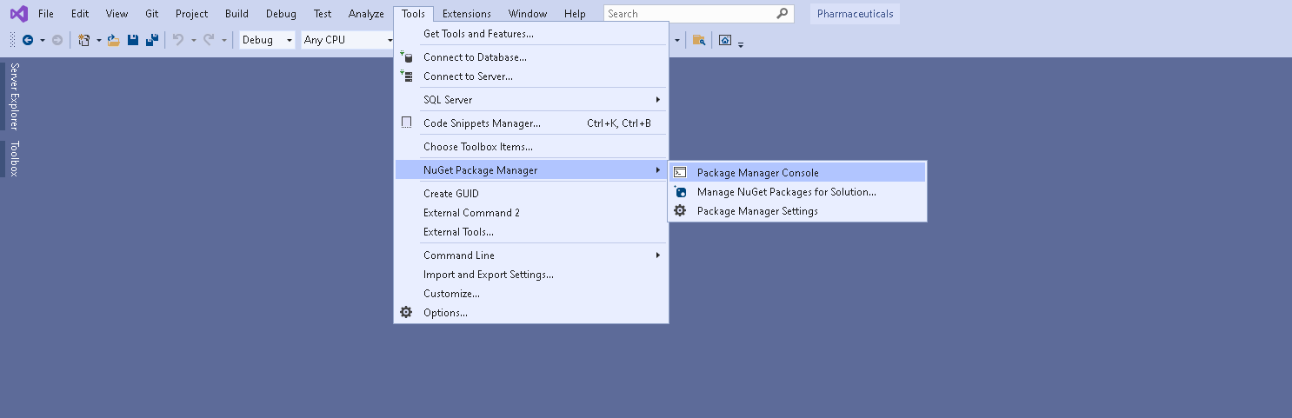

Change Default project → PharmaceuticalsAPI

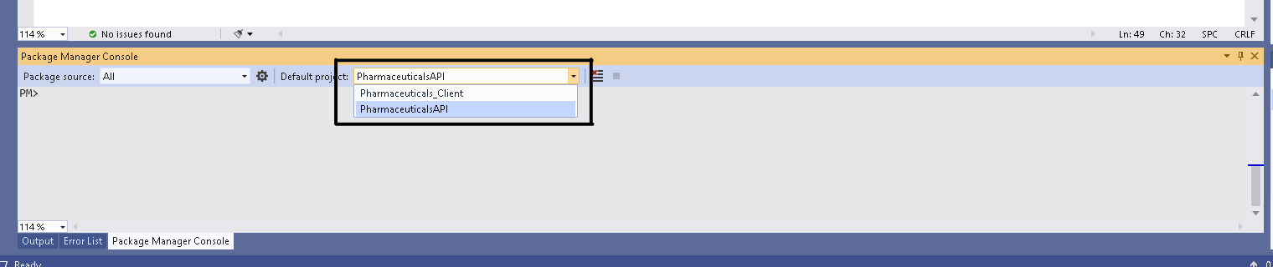

Type: update-database
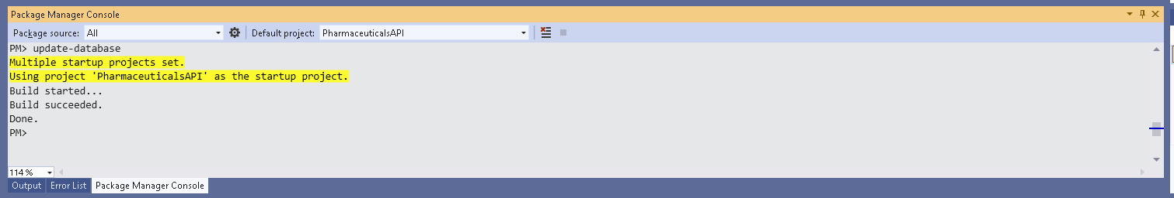

- Start browse web
- The main admin page: http://localhost:29291/Admin/Login

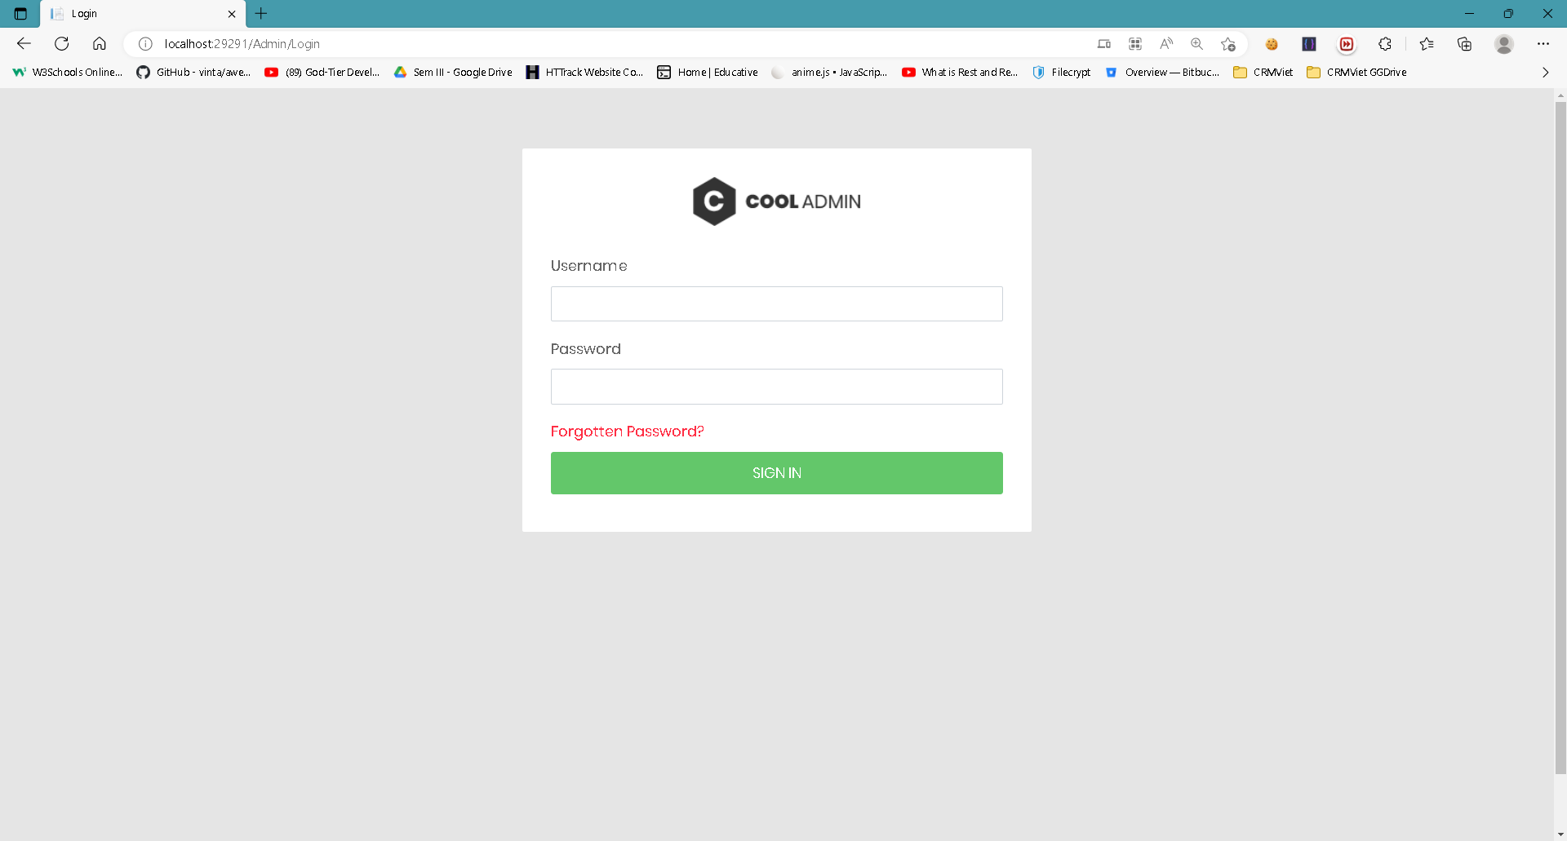

- Default Admin :
- Username : admin
- Password : 123456
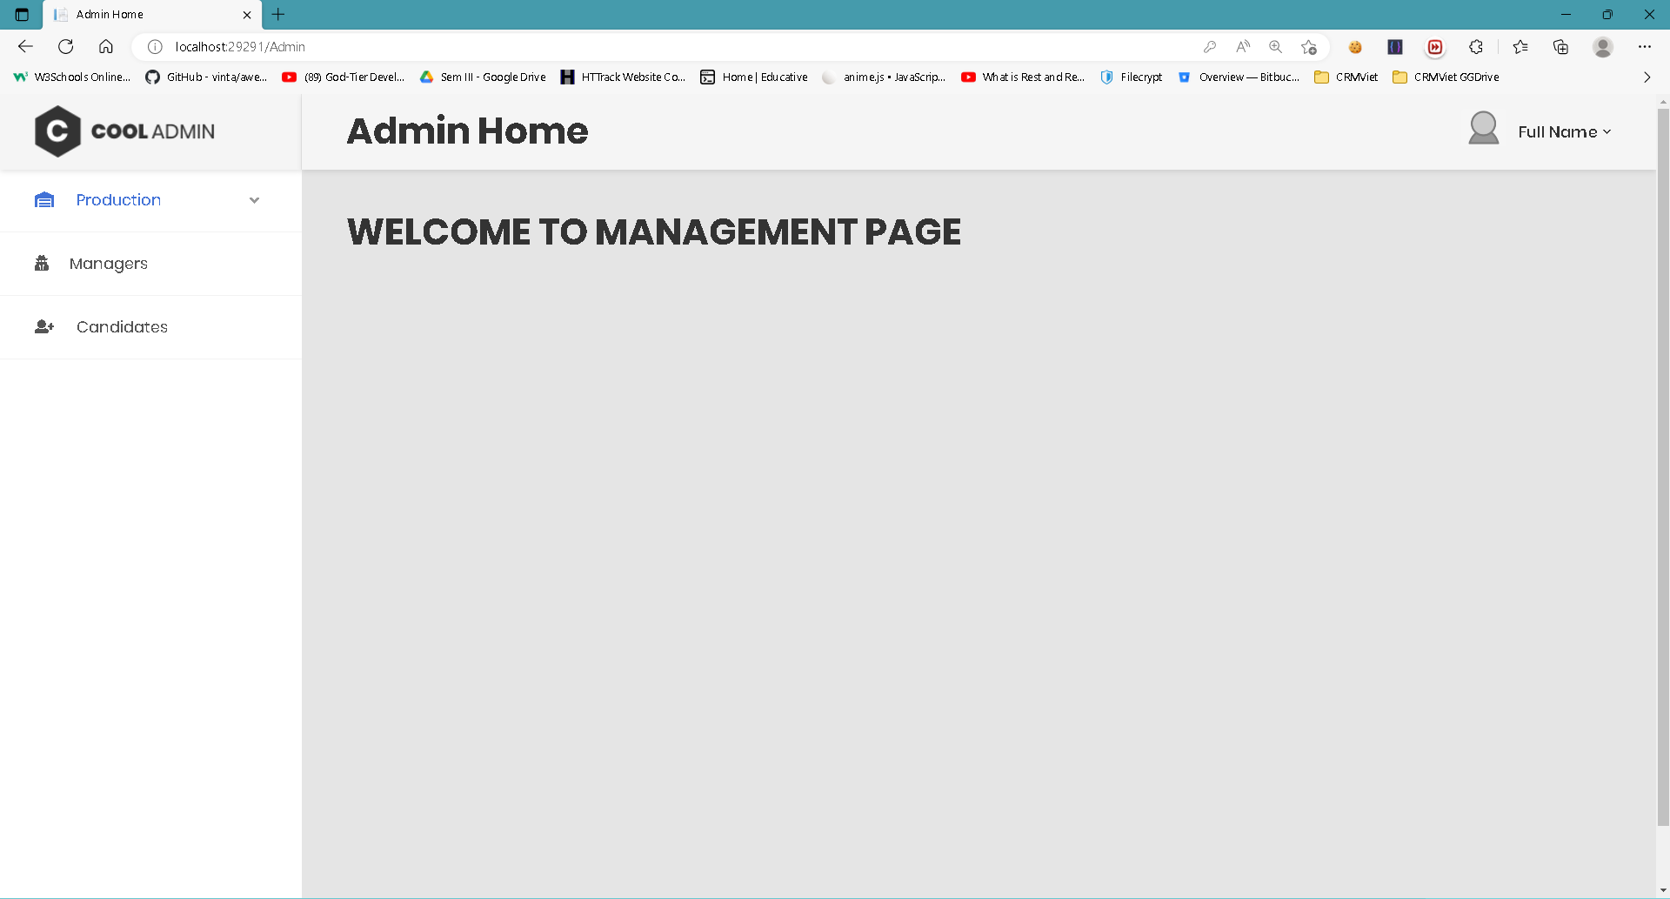

THE END

